# What the JS! (Cryptography)

Pretty much everyone did this challenge because of the very obvious hint I had given.

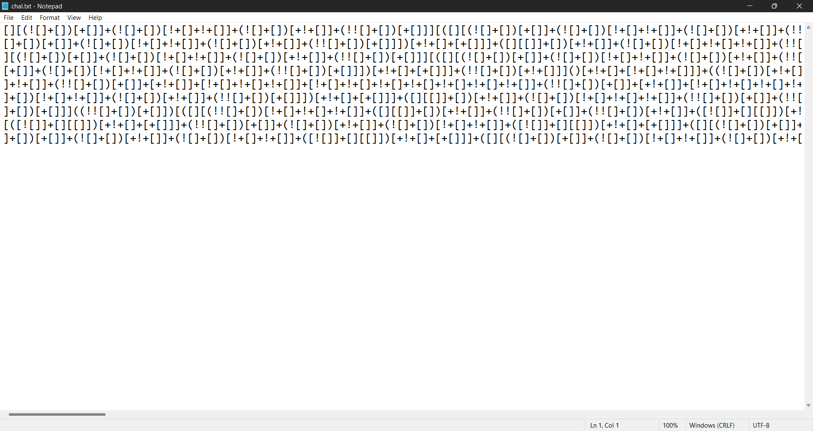

The code is basically [JSFuck](https://en.wikipedia.org/wiki/JSFuck), an esoteric language. (It is valid JavaScript code that is written using only 6 characters.)

So, running the code in the Chrome Dev Tools console or on [JSUnfuck](https://codertab.com/jsunfuck) gives us the flag.

